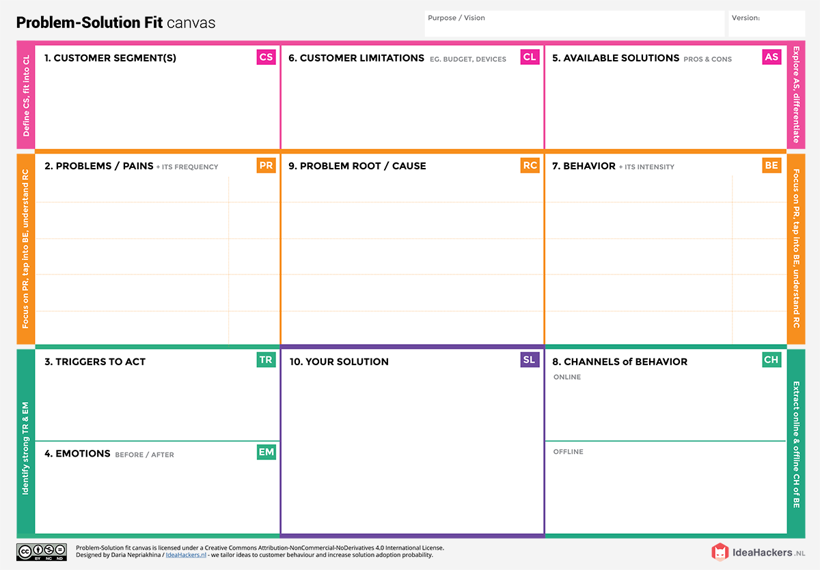

Most commonly used irrigation type is Drip irrigation the most common disadvantage is when the water is not filtered properly there will be clogs and the tubes will get affected easily.

In smart farming we can use solar empowered smart irrigation system to overcome this

TEAM ID: PNT2022TMID17581

Project Design Phase-I – Solution fit

PROJECT TITTLE:SMART FARMER

As when the productivity increases farmers will be

satisfied. They will not worry about the loss. Irrigation will be more efficient than before.

we will reach the customer directly ask

about their problems and provide effective

solutions if their problems match our

application and provide them knowledge

about our application to make their farming

even more easier.

In online mode will do digital marketing using

advertisements.

As when the productivity increases farmers will be

satisfied. They will not worry about the loss. Irrigation will be more efficient than before.

To get correct accuracy on what to be done on

the farm and to produce more crops and livestock

quantitavely.

The customers will reach us when they don’t have idea on how to analyse the soil and to improve the current irrigation system.

When there is no knowledge about the soil

problem arises on what to be sowed, climatic

conditions also play a major role. Knowledge on

how to water the plants accordingly.

To make farming easier more quantitately.

1.Monitoring farms climatic conditions.

2.Automatic systems for irrigation and Fertilization.

3.Soil analysis.

The availabilty of device, proper Network facilities

and budget are several constraints ,Knowledge about

the application

Farmers are our Customers.